**SUPERSTORE SQL QUERIES AND OUTPUT**

**GENERAL QUESTIONS**

1. **How many unique cities does the data have**

1. **In which state is each city?**

**PRODUCTS**

**1. How many unique product Category does the data have?**

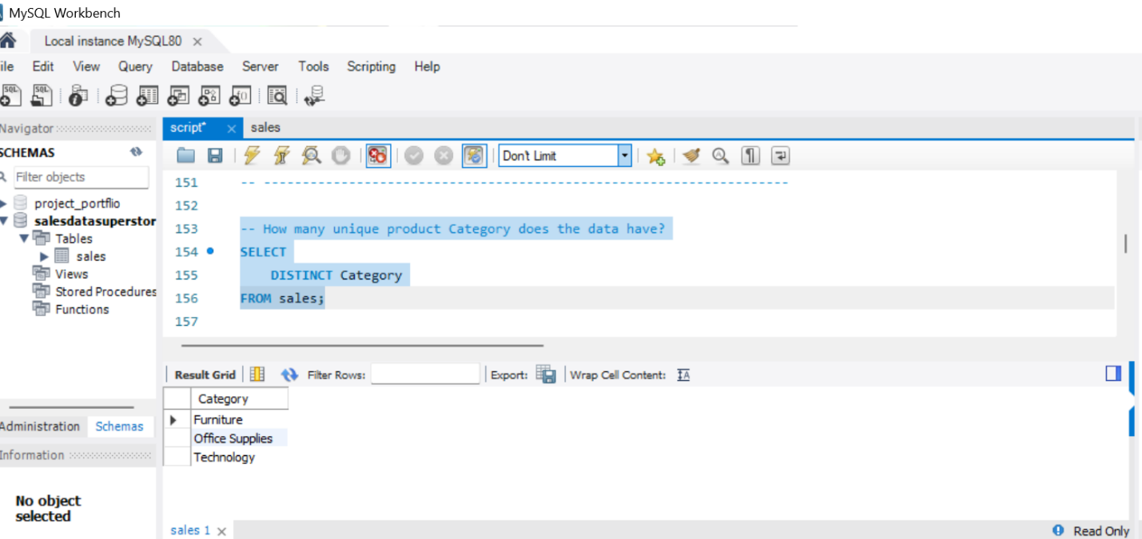

**2.What is the most selling product Category?**

1. **What is the total revenue by month?**

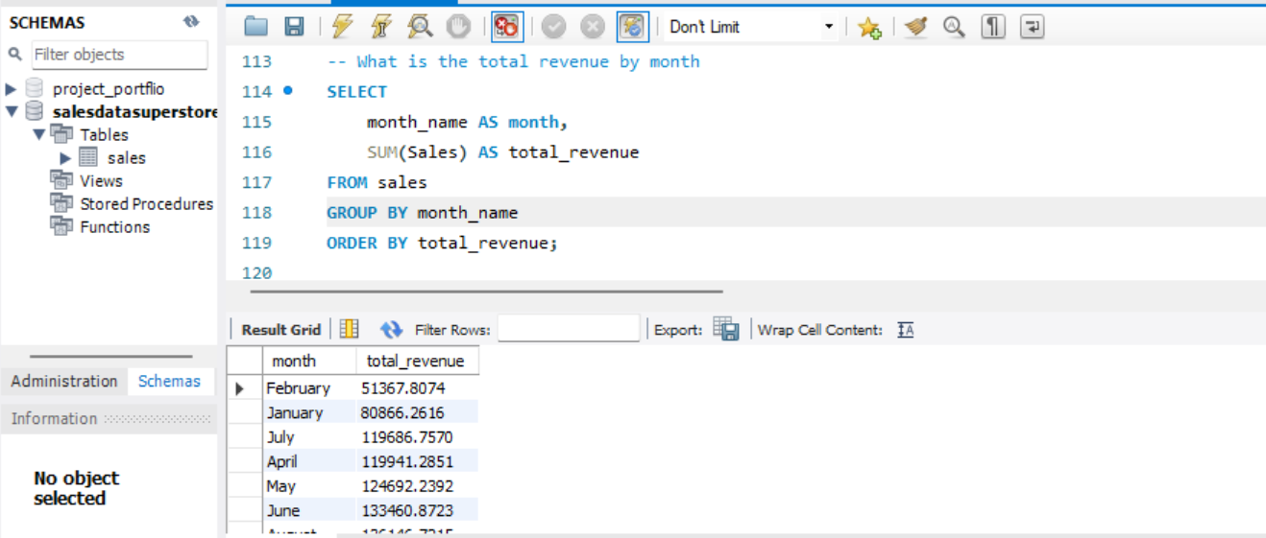

1. **What month had the largest COGS?**

1. **What product Category had the largest revenue?**

1. **. What is the city with the largest revenue?**

1. **. What product category had the largest VAT?**

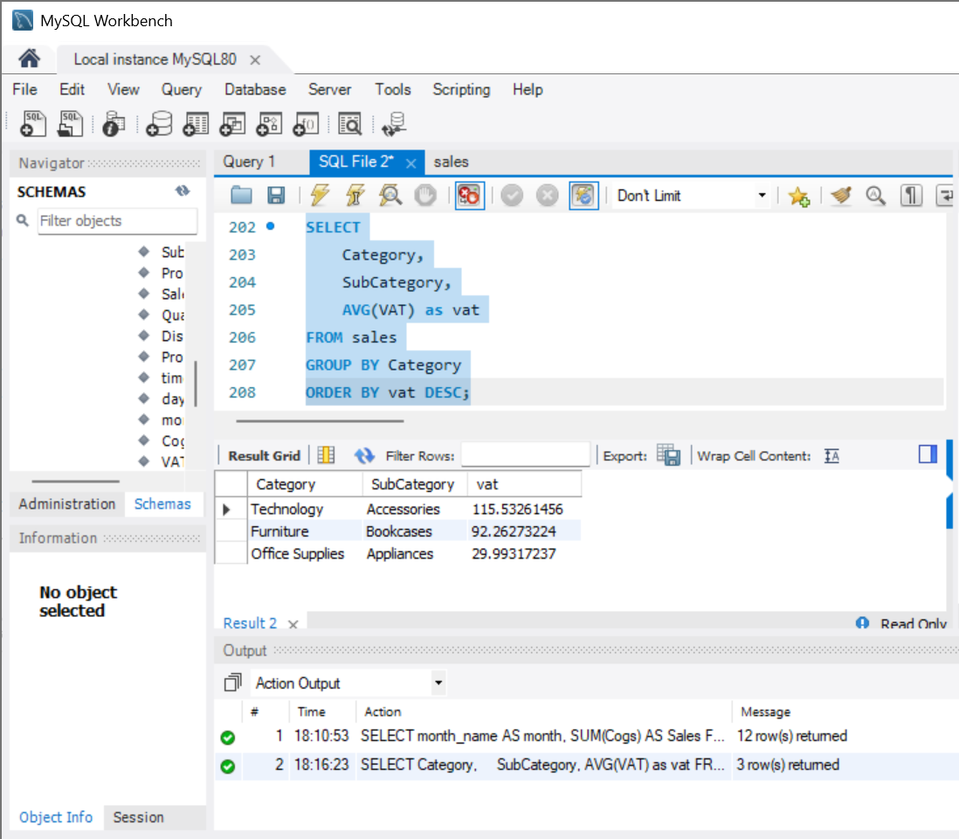

1. **- What product category had the largest discount?**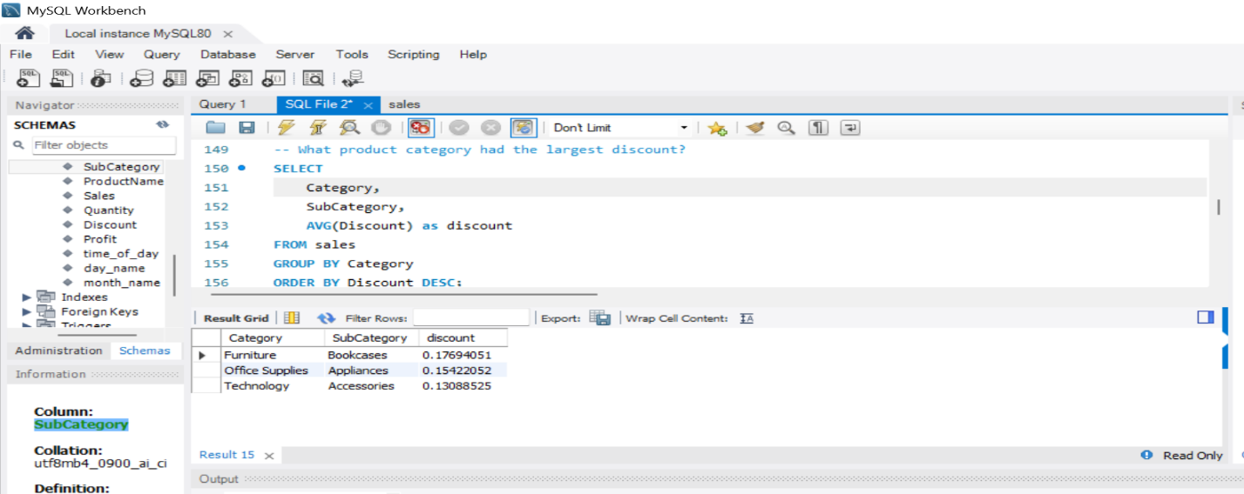
2. **Fetch each product Category and add a column to those product line showing "Good", "Bad”. Product Category Good if its greater than average sales**

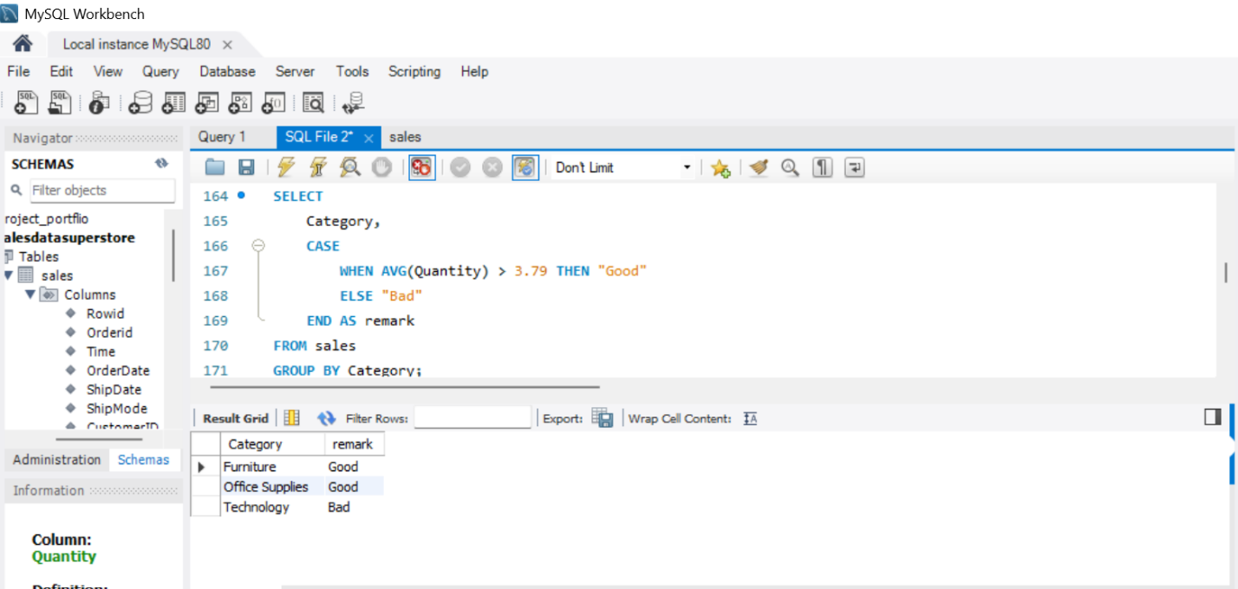

**10.What is the most common product category by Product name?**

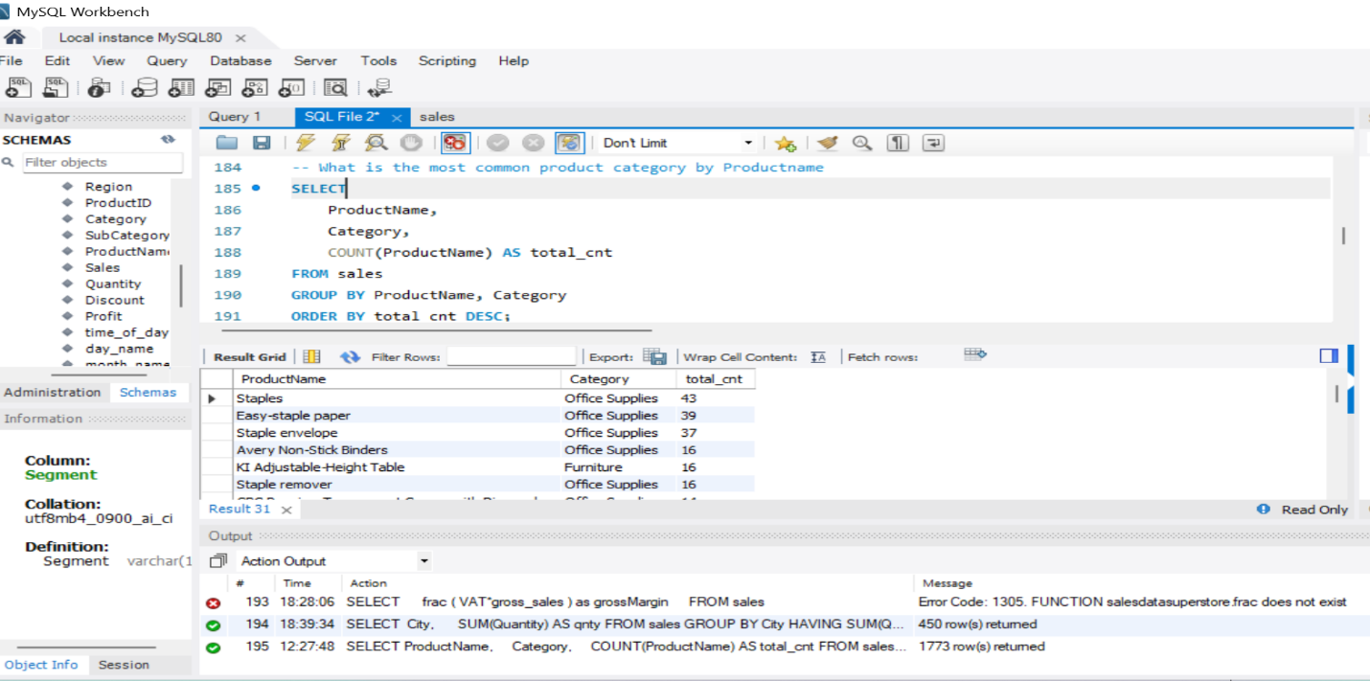

**CUSTOMERS**

1. **How many unique customer does the data have?**

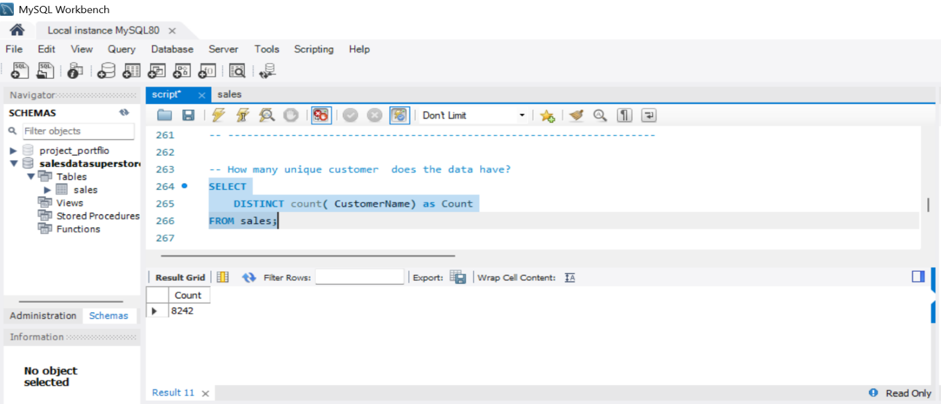

1. **What is the most common customer type?**

1. **What is the City of most of the customers?**

1. **How many days it takes for the product to get dispatched?**

1. **Which day of the week has the best sales?**

1. **Which day of the week has the best sales per Segment?**

**SALES**

1. **Number of sales made in each time of the day per weekday?**

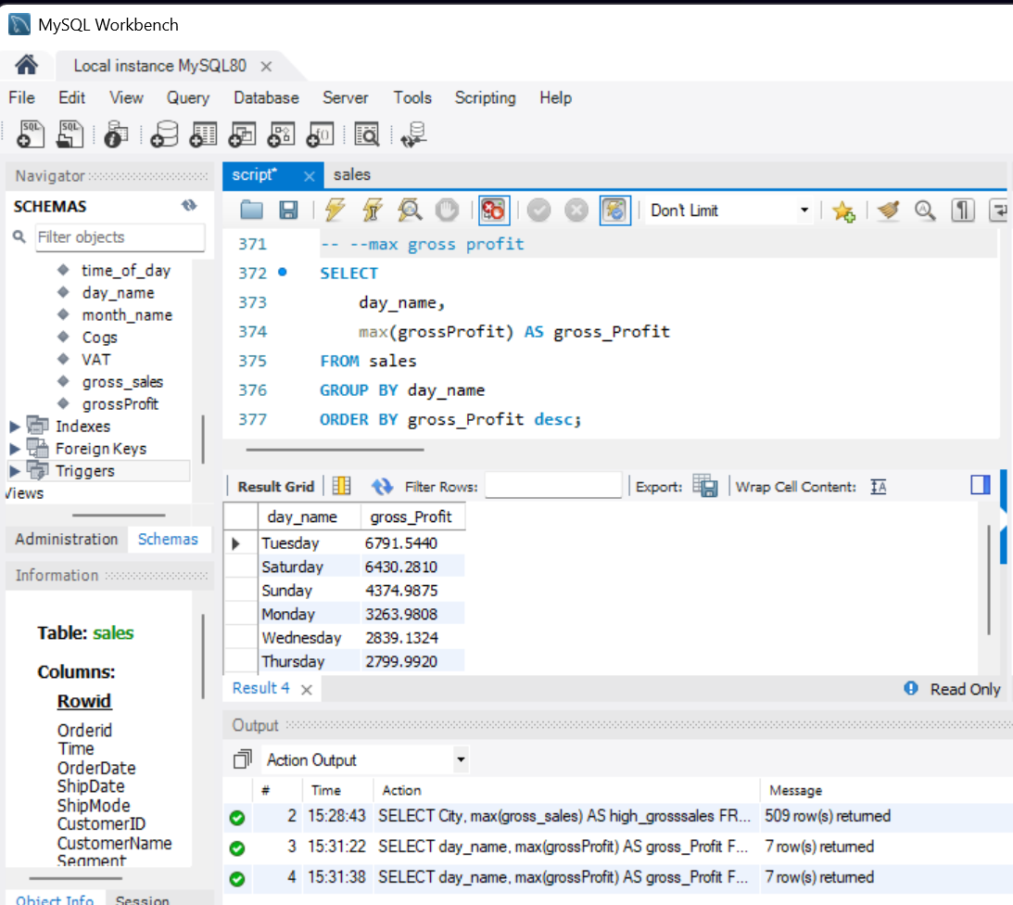

1. **Which of the customer types brings the most revenue?**

1. **Which city has the largest tax/VAT percent?**

1. **Which customer type pays the most in VAT?**

1. **max gross_sales**

1. **max gross profit**

